SIMATS ENGINEERING (SAVEETHA SCHOOL OF ENGINEERING)
Department of Computer Science and Engineering
CO1 ASSESSMENT TOOL 2 – Agile Sprint Planning & User Story Workshop

Course Code: | CSA10 / CSA1005 | Course Title: | Software Engineering
CO Assessed: | CO1 | Assessment: | Assessment Tool 2 – Agile Sprint Planning & User Story Workshop
Weightage: | 20% | Total Marks: | 25
CO1 Statement: | Apply advanced methodologies and agile project management techniques to manage software projects effectively
Student Name: | S. Rohit Ram | Reg. No.: | 1922260146
Date: | 20/10/2026 | Duration: | 60 minutes

Code of Conduct
I, S. Rohit Ram (Reg. No. 1922260146), certify that this submission is my original work and that I have adhered to the guidelines specified for this assessment. I understand that any violation of academic integrity rules will result in disciplinary action.
Signature of the Student: _________________________

Annexure A – Agile Sprint Planning & User Story Workshop
  - Define a clear sprint goal and describe the expected sprint deliverables, including the features to be completed at the end of the sprint.
Case Study: Intelligent Agricultural Equipment Sharing Platform
Course: Software Engineering | Course Code: CSA10 / CSA1005 | Student: S. Rohit Ram | Register Number: 1922260146
1. Project Vision and Industry Context
Small and medium-scale farmers may not be able to afford expensive agricultural machinery such as tractors, harvesters, seeders, and irrigation equipment. At the same time, privately owned equipment may remain unused for significant periods. The proposed platform connects farmers who need machinery with equipment owners who can rent it out.
Project vision: To provide a convenient, transparent, and reliable digital platform where farmers can discover available agricultural equipment, reserve it for a required period, arrange delivery, make rental payments, and maintain usage records.
Project Objectives
• Register farmers and equipment owners.
• List agricultural equipment with descriptions, rental charges, location, and availability.
• Allow farmers to search and view equipment availability.
• Manage equipment bookings and rental periods.
• Calculate rental charges and record payments.
• Coordinate delivery and return arrangements.
• Track equipment usage and rental history.
• Support ratings and reviews after a rental.
Key Stakeholders
• Farmers / renters – search for equipment, book it, pay rental charges, and review the service.
• Equipment owners – list machinery, set rental prices, manage availability, and approve or fulfil bookings.
• Delivery providers – coordinate equipment pickup and delivery where offered.
• Platform administrator – verify accounts/listings, resolve disputes, and monitor platform activity.
• Payment service provider – process payments and return transaction status.
2. Epics and User Stories
• Epic 1 – User Registration: As a farmer or equipment owner, I want to create an account, so that I can use the platform according to my role.
• Epic 2 – Equipment Listings: As an equipment owner, I want to add machinery details, rental price, location, and available dates, so that farmers can find equipment to rent.
• Epic 3 – Search and Availability: As a farmer, I want to search and filter equipment by type, location, price, and dates, so that I can identify suitable machinery.
• Epic 4 – Booking Management: As a farmer, I want to request an available equipment slot, so that I can reserve machinery for my farming activity.
• Epic 5 – Rental Payment: As a farmer, I want to see the estimated rental charge before confirming, so that I understand the cost.
• Epic 6 – Delivery and Return: As a farmer, I want to view delivery or pickup arrangements, so that I know how and when to receive the equipment.
• Epic 7 – Usage History and Reviews: As a farmer, I want to view past rentals and submit a rating, so that I can track my usage and share feedback.
3. Acceptance Criteria (Given–When–Then)
• User registration: Given a user enters all required valid details, when they submit the registration form, then the system creates an account and confirms successful registration.
• Equipment listing: Given an owner is logged in, when they submit equipment type, description, location, price, and availability, then the listing is saved and displayed in the equipment catalogue.
• Search: Given equipment listings exist, when a farmer selects equipment type and location, then the system displays matching listings and their availability.
• Booking: Given equipment is available for the selected dates, when a farmer submits a booking request, then the system records the request and prevents conflicting confirmed bookings for the same period.
• Rental charge: Given the daily rate and rental duration are known, when the farmer selects a booking period, then the system displays the calculated estimated charge before confirmation.
• Payment record: Given a booking has a payable amount, when payment processing returns a successful status, then the system records the transaction status against the booking.
• Review: Given a rental is marked completed, when the farmer submits a rating and review, then the system saves the feedback against the relevant equipment listing.
4. Prioritized Product Backlog
Priority is based on essential user value and dependencies. Registration and listings come first because search and booking depend on them.
5. Sprint Backlog – Sprint 1
Sprint duration: 2 weeks (proposed). Sprint 1 focuses on establishing the platform foundation and making equipment listings available for discovery.
• Task 1: Define farmer and equipment-owner account fields and registration flow.
• Task 2: Create the basic user registration and login screens.
• Task 3: Design the equipment listing data fields (type, description, location, rate, availability, owner).
• Task 4: Build the equipment listing creation form for owners.
• Task 5: Display saved listings in a catalogue view.
• Task 6: Test required-field validation, listing creation, and catalogue display.
6. Story Point Estimation and Justification
Estimation approach: Relative estimation using a Fibonacci-style scale (1, 2, 3, 5, 8). The values reflect relative effort, complexity, and uncertainty; they are planning estimates rather than hours.
• Registration and login – 3 points: a small, familiar workflow with basic validation.
• Equipment listing creation – 5 points: requires a structured form, validation, and saving multiple equipment attributes.
• Equipment catalogue display – 3 points: displays stored listing information in a consistent format.
• Search and availability – 5 points: filtering and date availability introduce additional logic.
• Booking management – 8 points: involves date conflicts, booking status, and coordination between farmer and owner.
7. Sprint Goal and Expected Deliverables
Sprint goal: Enable users to access the platform and allow equipment owners to publish agricultural machinery listings that farmers can browse.
Expected deliverables at the end of Sprint 1:
• Basic registration/login flow for farmers and equipment owners.
• Equipment listing form with required-field validation.
• Equipment catalogue showing submitted listings.
• Basic test cases and recorded test results for registration and listing functions.
• A short demonstration of the working Sprint 1 features.
Conclusion
The Agile plan delivers the platform incrementally, starting with user access and equipment listings before adding search, booking, payment, delivery coordination, and reviews. Prioritizing these dependencies helps the team deliver useful features in manageable sprints and collect feedback from farmers and equipment owners.
Rubrics for Calculation
Criteria | Excellent (5 Marks) | Good (3 Marks) | Satisfactory (2 Marks) | Needs Improvement (1 Mark)
Project Vision & Stakeholder Identification (30%) | Project vision is clear, comprehensive, and aligned with the problem statement. All relevant stakeholders and their roles are correctly identified. | Vision is clear with minor omissions. Most stakeholders are correctly identified. | Vision is partially defined. Some stakeholders are missing or incorrectly identified. | Vision is unclear or incomplete. Stakeholders are poorly identified or missing.
Epics & User Stories (25%) | Epics are well-defined and user stories are complete, follow Agile format, and fully capture functional requirements. | Epics and user stories are mostly complete with minor formatting or requirement issues. | User stories are partially complete with limited Agile structure. | User stories are incomplete, unclear, or do not follow Agile practices.
Acceptance Criteria (20%) | Acceptance criteria are specific, measurable, testable, and aligned with all user stories. | Acceptance criteria are mostly clear and testable with minor gaps. | Acceptance criteria are partially defined and lack clarity or completeness. | Acceptance criteria are missing or not aligned with user stories.
Product Backlog Prioritization & Sprint Planning (15%) | Product backlog is logically prioritized, sprint backlog is realistic, and task breakdown is complete. | Backlog prioritization and sprint planning are mostly appropriate with minor issues. | Prioritization or sprint planning is partially complete with limited justification. | Backlog prioritization and sprint planning are poorly organized or incomplete.
Story Point Estimation, Sprint Goal & Presentation (10%) | Story point estimation is well justified, sprint goal is clear, deliverables are realistic, and presentation is professional and well organized. | Estimation and sprint goal are mostly appropriate with minor inconsistencies. Presentation is clear. | Estimation or sprint goal lacks justification. Presentation is adequate but incomplete. | Estimation is unrealistic or missing. Sprint goal, deliverables, and presentation are unclear or incomplete.

Criteria | Mark
Project Vision & Stakeholder Identification (30%) | /5
Epics & User Stories (25%) | /5
Acceptance Criteria (20%) | /5
Product Backlog Prioritization & Sprint Planning (15%) | /5
Story Point Estimation, Sprint Goal & Presentation (10%) | /5
TOTAL | /25

Priority | Backlog item | User value / dependency | Story points
P1 | User registration and login | Required before users can manage listings or bookings | 3
P2 | Create and view equipment listings | Core inventory needed for search | 5
P3 | Search equipment and view availability | Helps farmers identify suitable machinery | 5
P4 | Request and manage bookings | Core rental workflow; depends on listings and availability | 8
P5 | Calculate rental charges | Supports informed booking; depends on rental dates and rates | 3
P6 | Record payment status | Needed for payment tracking; depends on booking amount | 5
P7 | Delivery / pickup arrangements | Improves coordination after booking | 5
P8 | Rental history and reviews | Useful after completed rentals | 5

JIRA TASK BOARD – PROJECT PROGRESS
Intelligent Agricultural Equipment Sharing Platform
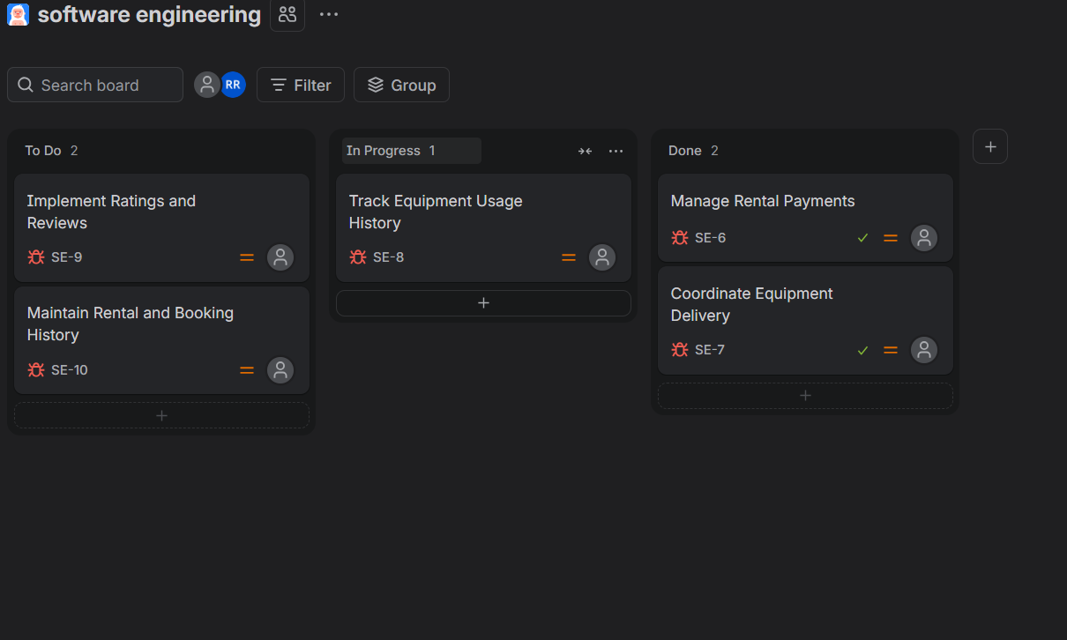
Figure: Jira board showing task progress across To Do, In Progress, and Done.

AGRI-SHARE WEBSITE DESIGN
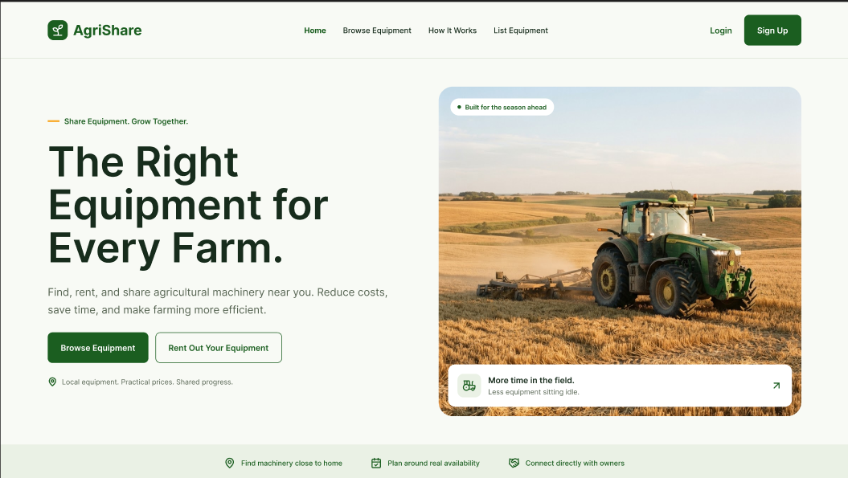
Figure 1: AgriShare home page design for agricultural equipment sharing.
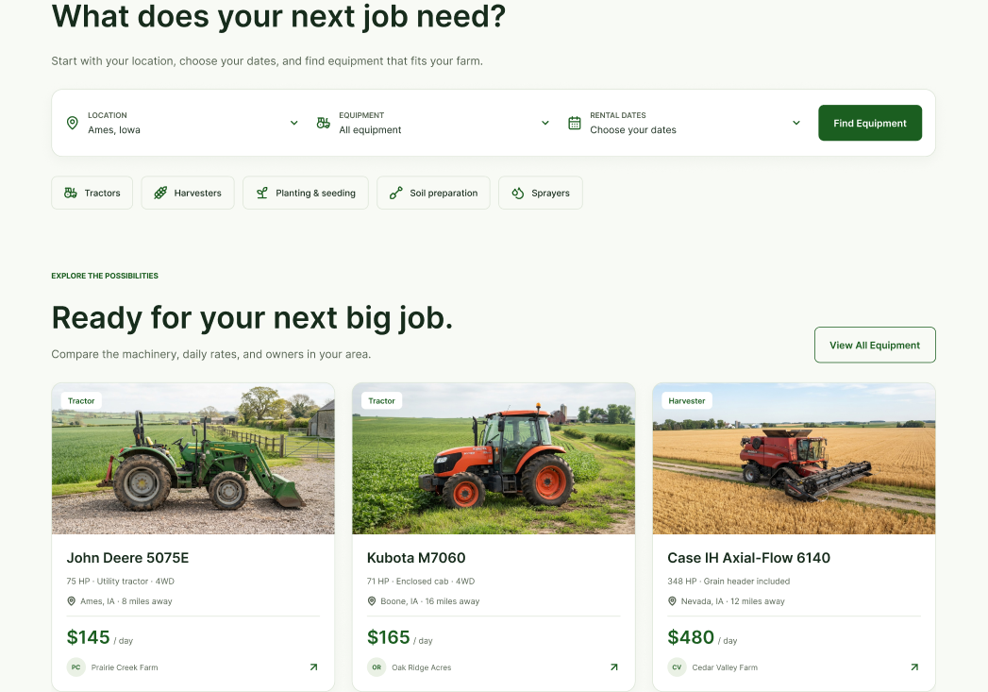
Figure 2: Equipment search and rental listing page design.

